**Project Planning using Agile Methodologies**

**Project Progress Tracking**

|  |  |
| --- | --- |
| Date | 19 September 2022 |
| Team ID | PNT2022TMID43270 |
| Project Name | Signs with smart connectivity for better road safety |
| Maximum Marks | 2 Mark |

**the Internet of Things in Real Life**

The Internet of Things (IOT) is a network of connected devices and systems that collect and exchange data. The data generated by [IOT devices](https://www.raypcb.com/iot-devices/) can help businesses [evaluate](https://www.raypcb.com/tips-for-evaluating-a-pcb-manufacturer-or-a-pcb-assembler/) processes and identify inefficiencies. The connected smart elements can also help enterprises to monitor their premises and track their customers. This data can help companies develop more personalized customer experiences and optimize their supply chains.

The Internet of Things is a network of embedded devices connected to the internet. It enables a smart device to interact, collaborate, and learn from one another. One of the industries that have embraced IoT is wearable technology. Some examples of this technology include Fit Bits and smart watches.

[Smart buildings](https://new.siemens.com/global/en/company/topic-areas/smart-infrastructure/smart-buildings.html) are another example of IoT use cases. They can help control the temperature of a room or an entire building. They can also detect the number of occupants in a room or office. This means they can turn on the air conditioner when necessary. A [smart farming](https://www.raypcb.com/iot-in-agriculture/) system using IoT can monitor light, temperature, and soil moisture. The data can also help automate irrigation systems. Smart cities are also a great way to alleviate traffic and address environmental issues like pollution by coming up with an air pollution monitoring system.

As more devices connect, the IoT becomes more critical for organizations and businesses. It helps organizations operate more efficiently, understand customers better, and improve decision-making processes. These improvements are beneficial for everyone

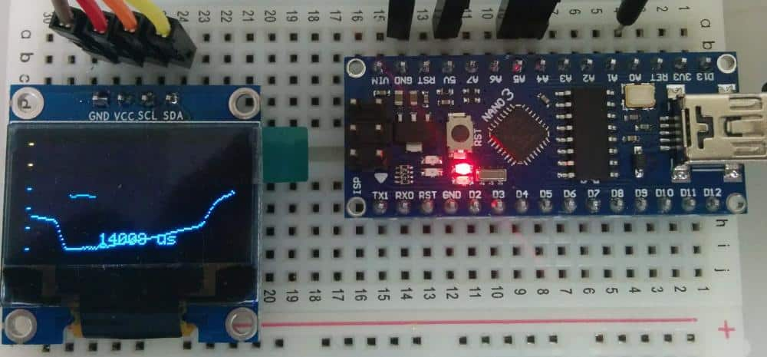

## Interesting IoT project ideas

### Home Automation Using Raspberry Pi and MQTT

MQTT is an open-source protocol that can be helpful in-home automation projects. It can be beneficial with low-cost development boards such as the [Raspberry Pi](https://www.raypcb.com/raspberry-pi-pcb/). The Raspberry Pi has a Mosquitto broker, which is essential to the MQTT protocol. It also runs Node-RED, a Home Automation Platform that supports MQTT. Using Node-RED, you can create a network of MQTT-enabled devices, such as sensors. This software allows you to set up buttons to control outputs and chart display sensor readings**.**

### IoT-Based Smart Grid System

An IoT Based Smart Energy Grid System is an energy management system that uses Internet of Things (IoT) technology to monitor and control the system. It can help improve system reliability, efficiency, and sustainability. IoT technologies can also improve system security and congestion management.

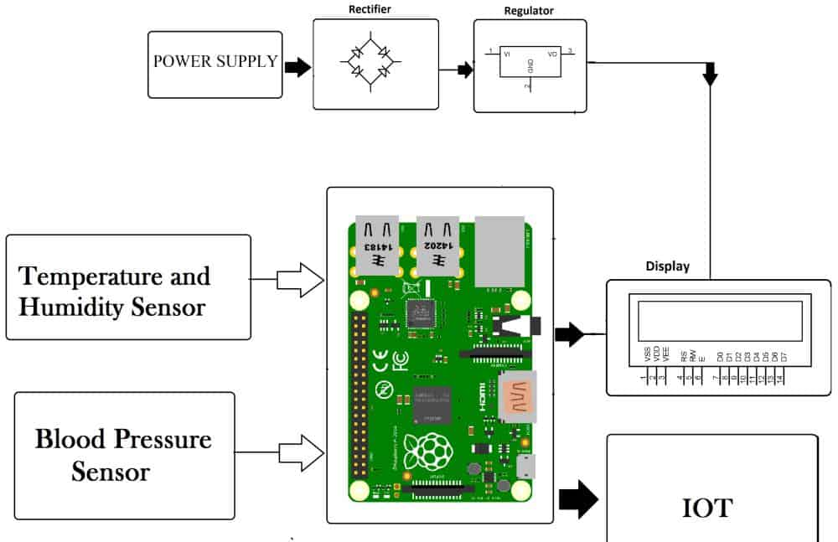

### ESP8266 IoT Energy Monitor and Over Current Cut-Off

The ESP8266 IoT Energy Monitor & Over Current Cut-off is a WiFi-based IoT device that can detect the current of AC appliances and break the circuit accordingly. The device connects to a home Wi-Fi network and displays a power consumption graph.

### IoT Mesh Network smart Agriculture System

An IoT Mesh Network Agriculture System uses data generated by sensors and devices to control and monitor farming processes. For example, it can control the level of large tanks which store fuel, smart irrigation system, fertilizer, or livestock feed. The system can also provide real-time feedback about the condition of a field through a web browser interface. The information may then help control wired or wireless devices on the farm.